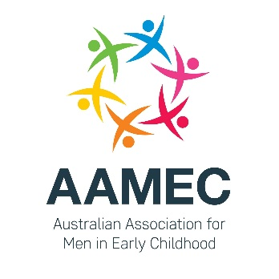
&

MENu 2018

Male Educators on the Fringe

9.15am Registrations Open
9.45am – 10.00am Acknowledgement of Kaurna country
10.00am – 10.15am Dr Martyn Mills-Bayne (MENtor Program)
Conference opening and welcome
10.15am – 11.15am Ben Jackson (Keynote)
Winner of the 2017 Australian Family Early Education & Care Awards National Educational Experience Rising Star and creator of MANscaping – The Male Educator social media platform.
11.15am – 11.30am Morning Tea (provided)
11.30am – 12.15pm Professor Lester-Irabinna Rigney (University of South Australia)
In 2011 Professor Rigney won the National Aboriginal scholar of the Year NAIDOC. In the same year he was appointed to the First Peoples Education Advisory Group that advises on Aboriginal and Torres Strait Islander early childhood and school education.
12.15pm – 12.30pm Official launch of the Australian Association for Men in Early Childhood
12.30 – 1.15pm Lunch (provided)
1.15pm – 2.00pm Dr Vaughan Cruickshank (University of Tasmania)
Vaughan is a Lecturer in Health and Physical Education. His research is focussed on practical strategies that male primary teachers can use to cope with the gender related challenges they face in their profession.
2.00pm – 3.00pm Molly Rhodin (Down to Earth Practical Solutions)
Molly is a coach, a leader, a thinker, a super-creative teacher and a mentor to many in early childhood education for almost 30 years.
3.00pm – 3.15pm Break
3.15pm – 4.15pm Educator Panel
Panel members: Ben Jackson (Day One ELC), Steven Cameron (Barbara Kiker Memorial Kindergarten), Badakhsh Jeizan (City West CCC) Brett Gent (Lady George Kindergarten), Rob Lister (GowrieSA).
4.15pm – 4.30pm Wrap Up / Close of Conference / MENu 2019

Saturday 17 February 2018, University of South Australia, City West Campus, North Terrace, Adelaide.
$200 per person ($100 student concession), Bookings: Eventbrite

